THE INF-FNI PETANQUE TOURNAMENT 2021
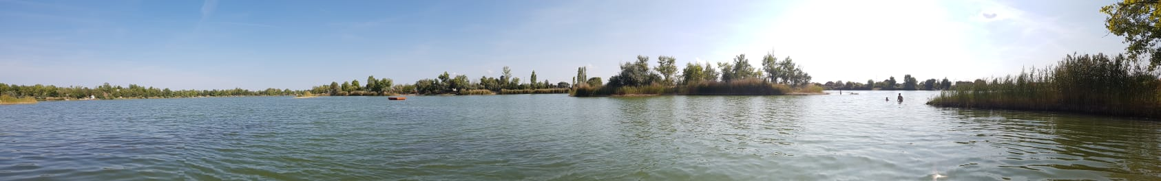
This year INF could celebrate the 40th edition of its Petanque Tournament thanks to MNE (Association of Hungarian Naturists) and FENHU (Federation of Naturists in Hungary) at the Camping Oasis Natura near Budapest.
Even though the vast majority of the players were Hungarians and Germans from FENHU and DFK respectively, members of the FBN (Belgium), FEN (Spain), INA (Ireland), SNU-UNS (Switzerland), ÖNV (Austria without players) and NFN (the Netherlands) -this contributed with great help alongside DFK- also participated.
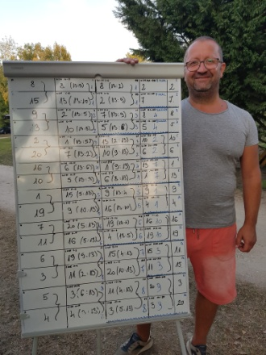
The organizers not only contributed to the INF offering their place and their work during this difficult pandemic period but also showed us how valuable they are as a Naturist group for this movement by their outstanding human resources.
Peter, from the previous preparation until the end, always looked after us very nicely; even our arrival time was very late, two camp workers (one of them with knowledge of Spanish) picked us up. Starting with the president of the FENHU everyone was wonderful.
The program was from Friday, September 3 to Sunday 5: though we were playing petanque most of the time, we also had music and dance during the Saturday evening.
Camping Oasis Natura contains a marvellous lake, the food was rich and varied. All participants received as gifts towel, Hungarian monuments calendar, typical salami and chili pepper powder, and reusable plastic cup. But the three top team winners (1. DFK, 2. DFK, 3. INA) also got spectacular baskets with typical products as well as their trophies and medals.
This Tournament was a perfect combination of Expertise of the veterans (DFK & NFN) and Enthusiasm of the beginners (FENHU & FEN). And Sieglinde played the real liaison for both parties.

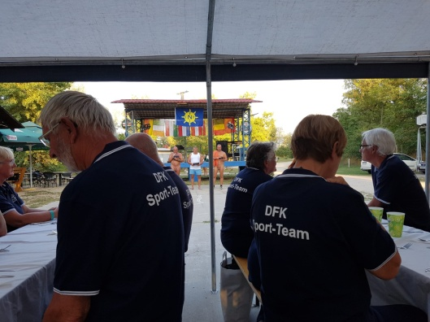
The beginners, for this time, didn't know about the lovely tradition that the players had been exchanging small gifts (for example, beer, little bottle of champagne, cup cover, etc.) with their opponents every match. Now we have learned for the next time.
In the personal field, happy to meet again Janos, the previous president of the FENHU, and his family. In my first participation, my new friends taught and couched this sports games, I played with my husband as a team, had a good time playing with other joyful players and enjoyed the final match with genuine pleasure.
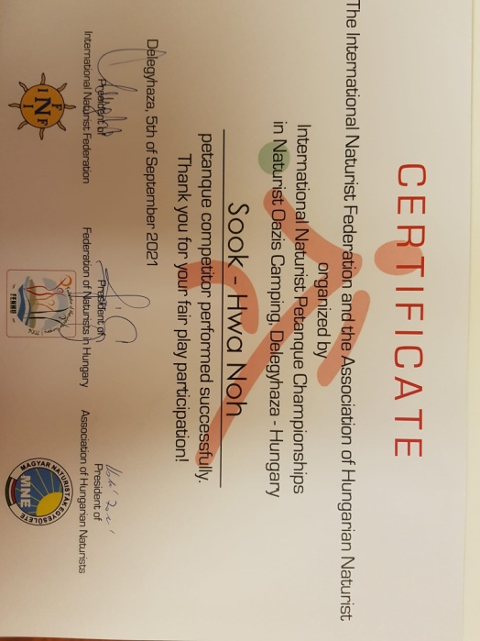

Sook-hwa Noh
EuNat Sports Officer

NOTE: If any Federation wants more pictures, ask for them to the Hungarian federation. They had an official photographer who took a lot of pictures.

